Cell Phone Policy
1st violation- device confiscated and returned to the student at the end of the day.

2nd violation- device confiscated and returned to parent or guardian.

3rd violation- device turned in daily at morning admit and retrieved at dismissal for 15 student days.

4th violation- device turned in daily at morning admit and retrieved at dismissal for the remainder of the year.

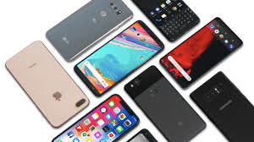

Students may use their cell phones while in the cafeteria during their lunch.

