Social Studies Department Summer Assignment (All grades)

Hello students the following Summer is for World History, African American History, American History and Social Science. The summer assignment will count as a 130 point test grade for the first quarter next school year. In order to receive the highest possible score, the assignment must be submitted by the second day of school. Directions on how to submit the assignment will be delivered on the first day of school. Students who have not submitted the assignment by the second day will have on week to do so and will have 20 points subtracted from the final project grade.

U.S. Presidential Election 2020

Upon completion of this summer assignment the students will be able to:

- identify, describe and evaluate each of the 2020 Presidential candidates.
- analyze, describe, evaluate the primary political issues and each candidates
position on these issues.
- self-evaluate and identify political and social positions that best reflect the
student's beliefs, values and goals.
- the students will apply what they have learned, select the Presidential
candidate they would support, and provide evidence to support their position.

Part 1: Answer in complete sentence form and post screen shots as directed.

The United States will hold its 59th presidential election on November 3, 2020. The winner of the 2020 presidential election will be sworn into office on January 20, 2021. Through this Web quest you will examine your political views and identify the political party that best represents your views.

1. In the space below provide the name and political party of each candidate that you know.

2. Which candidate and political party do you currently support?

NEXT:

Take the 2020 Political Quiz to see how your political beliefs match your political party and the candidates that you support. Pay close attention to the topics and categories. Also, use the expand feature on issues that matter the most to you or that you do not fully understand. Review polls to see what percentage of people agree with you on specific issues as well.

Go To: https://www.isidewith.com/political-quiz

Replace my Screen Shot with yours

3. Share a Screen Shot of how your responses match up with U.S. political parties.

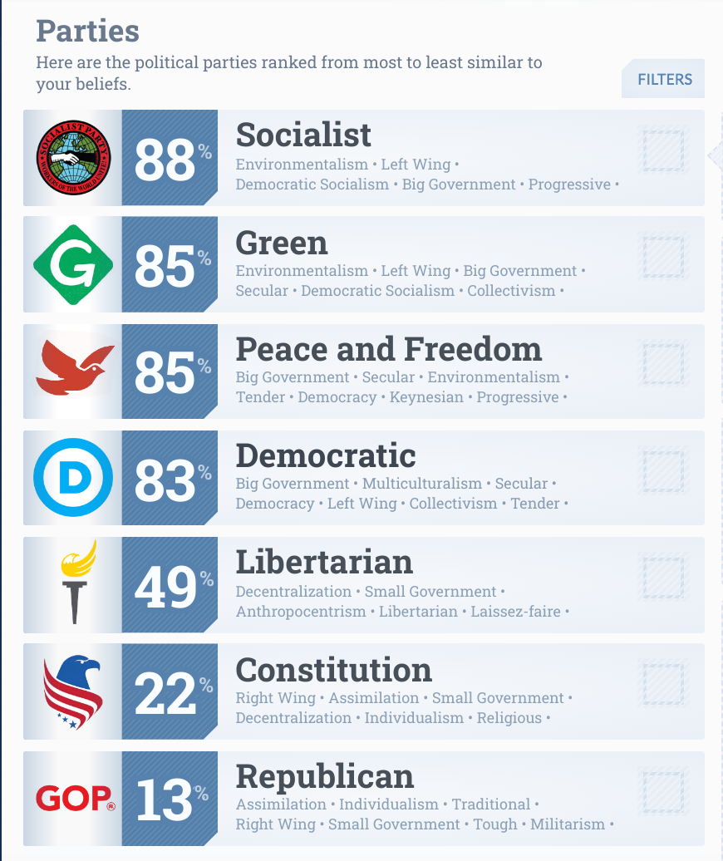
sample

4. Share a Screen Shot of the chart that represents your political ideology.

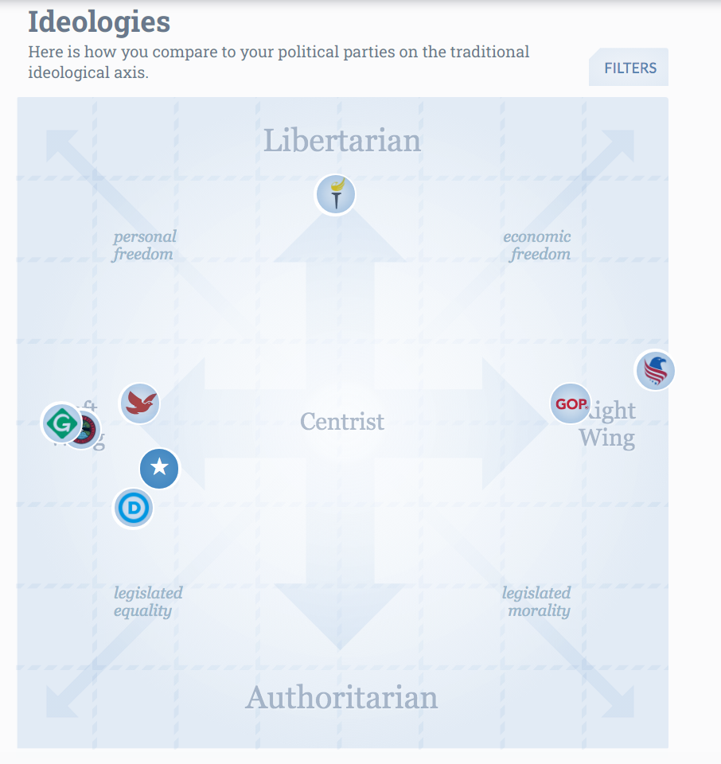sample

5. Where do you fall, to the left center or right? What does it say about you politically?

6. According to the survey which presidential candidate would you vote for? Which political candidate would be least likely to vote for? Were the results of the survey accurate.

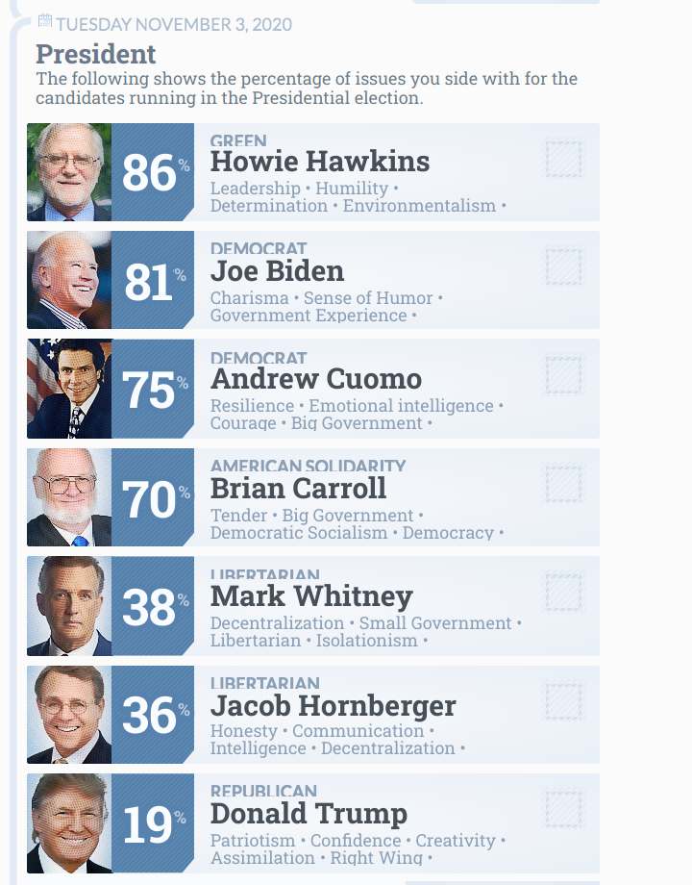 sample

7. Review the themes and how your responses correlated. According to the survey where do you stand in regards each of the following themes. Were you extreme left, moderate left, neutral moderate right, extreme right and which political party best aligns with your views within each theme.

a. Collectivism vs Individualism

b. Progressive vs Traditional

c. Tender vs Tough

d. Unilateralism vs Multilateralism

e. big government vs small government

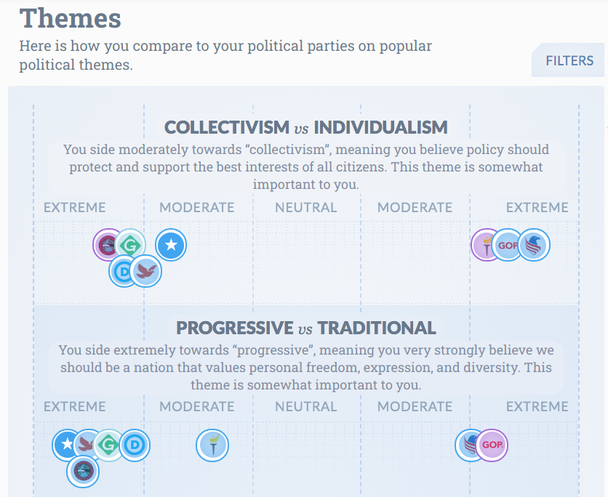 sample

Part 1: Rubric

______ of 10 Points 1 through 7 were submitted on time and were 100% complete.

______ of 21 Points based on the quality of responses for questions 1 thru 7. In order to receive the highest score make sure that your responses are in sentence form,
address all parts of the question and are thorough.

Part 2: Applying what you have learned. 100 Test points

If an election were held today at Girls High I believe that it is safe to say that the Democratic party candidate would win, just as the Republican candidate would probably get the fewest votes. To ensure that you are looking closely at the issues the Republican nor Democratic candidate can be selected for the following writing activity.

Prompt - Respond in essay form, 500 - 550 words

If you could vote for one of the third party (not a democrat or republican) candidates only who would it be and why? Provide specific details in regards to the candidate's political views
(3 minimum) and explain why they are important to you.

Part 2 Rubric - Students review the rubric in order to achieve the highest score

Criteria | Achievement Level
 | 1: Unsatisfactory | 2: Less than Satisfactory | 3: Satisfactory | 4: Good | 5: Excellent
Researching Presidential Candidates and the Electoral Process.  (Criterion to be met will include word counts, slide counts, and or multi-media usage, as required by process) | 0 points  No research is evident in the assignment. The criterion was not met on chosen process. | 40 points  Minimal research is demonstrated with less than 2 resources used in the assignment. The criterion for the chosen process in the assignment was loosely met. | 50 points  Adequate research is demonstrated.  with at least 3 resources used in the assignment. The criterion for the chosen process has been adequately met. | 60 points  Comprehensive research is demonstrated There are more than 3 resources The criteria for the chosen process in the assignment was met with a good amount of thought and details. | 65 points  Exhaustive research is evident with more than 4 resources used in the assignment. The criterion for the chosen process in the assignment was met with an abundance of thought and detail.
Mechanics of Writing  (Includes spelling, punctuation, grammar, language use) | 0 points  Surface errors are pervasive enough that they impede communication of meaning. Inappropriate word choice and/or sentence construction are employed. | 3 points  Frequent and repetitive mechanical errors distract the reader. Inconsistencies in language choice and/or word choice are present. | 5 points  Some mechanical errors or typos are present, but are not overly distracting to the reader. Audience-appropriate language is employed. | 7 points  Prose is largely free of mechanical errors, although a few may be present. The writer uses a variety of sentence structures and effective figures of speech. | 10 points  The writer is clearly in command of standard, written academic English.
Research and Citations  (In-text citations for paraphrasing and direct quotes, and references page listing and formatting) | 0 points  No references page and no citations are included. | 10 points  References page is present, but citations are inconsistently used. | 15 points  References page is included. Sources are appropriately documented, although some errors may be present. | 20 points  References page is present and fully inclusive of all cited sources. Documentation is appropriate and citation style is usually correct. | 25 points  In-text citations and a references page are complete. The documentation of cited sources is free of errors.

